;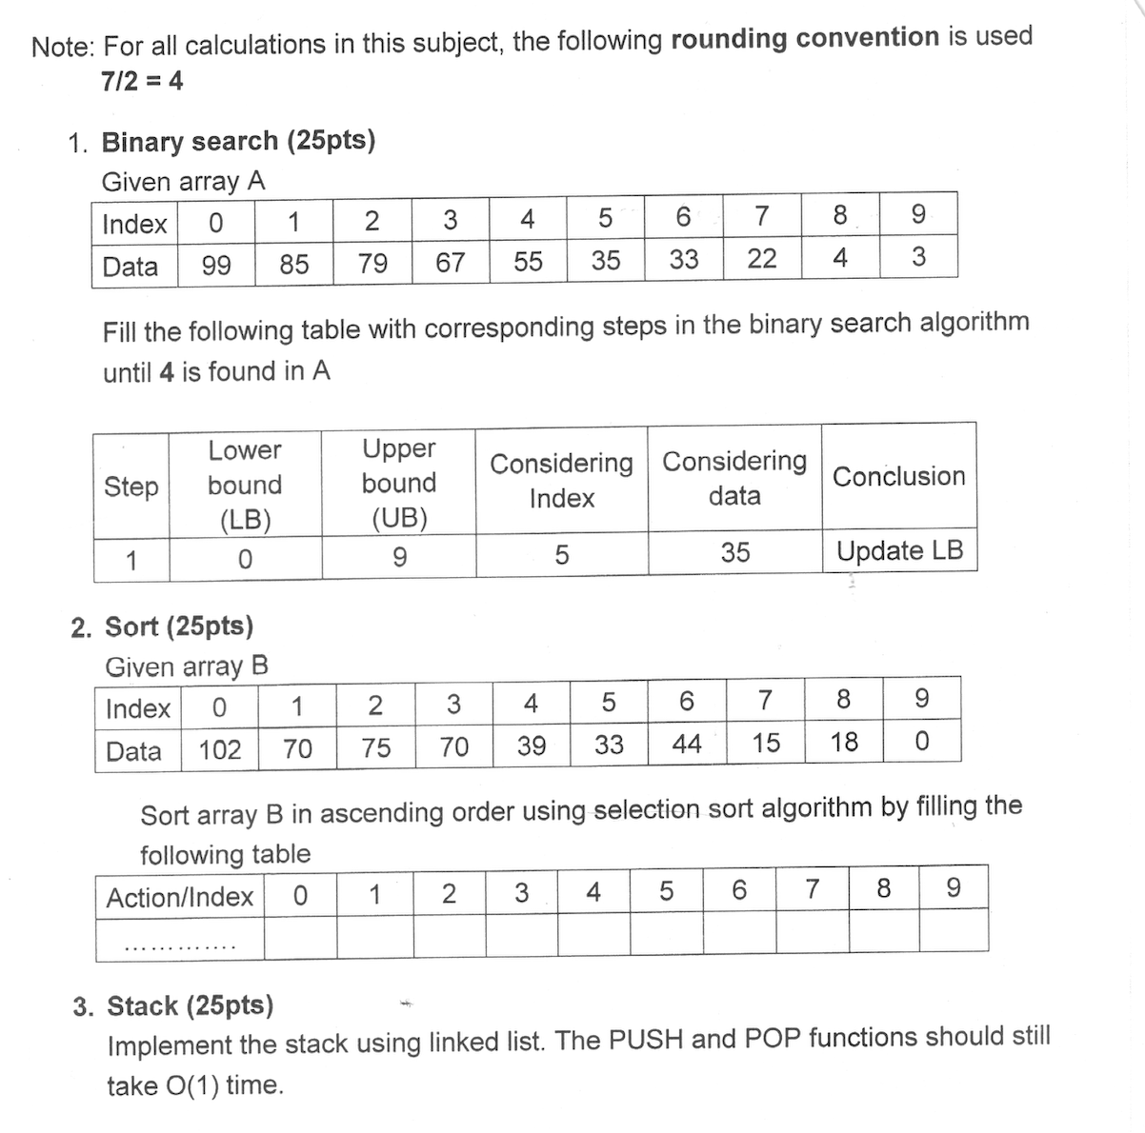

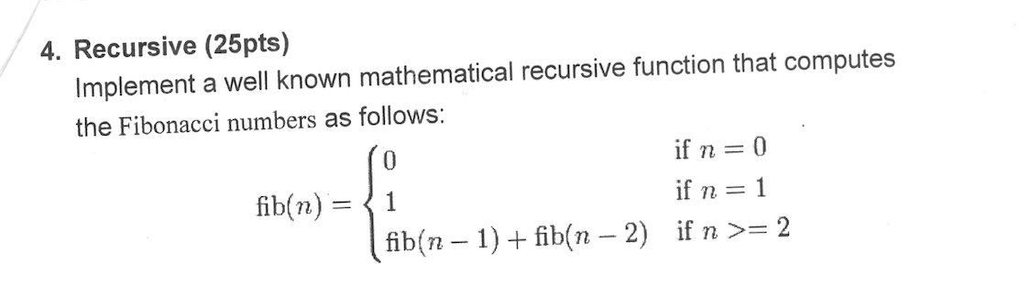

Câu 1: 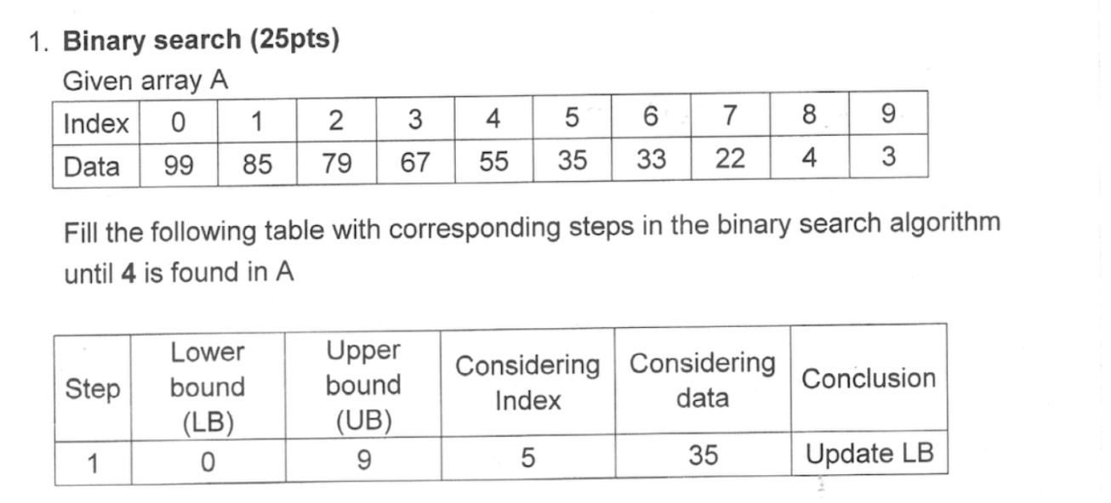

| Step | LB | UB | Considering index | Considering data | Conclusion |
| --- | --- | --- | --- | --- | --- |
| 1 | 0 | 9 | 5 | 35 | Update LB |
| 2 | 6 | 9 | 7 | 22 | Update LB |
| 3 | 8 | 9 | 8 | 4 | Found!! |

Câu 2:

Take B[0] is min value in the outer loop. Creating an inner loop, take B[1] is current value, go through the array and compare it to min value.If current value is less than min value, so min value = current value.Repeat the step until reach the last index. Swap it to B[0] and keep its position, then take B[1] is min value and repeat previous steps

| Action/Index | **0** | **1** | **2** | **3** | **4** | **5** | **6** | **7** | **8** | **9** |
| --- | --- | --- | --- | --- | --- | --- | --- | --- | --- | --- |
| B[0] is min value | 102 | 70 | 75 | 70 | 39 | 33 | 44 | 15 | 18 | 0 |
| Swap B[0] with B[9] | 0 | 70 | 75 | 70 | 39 | 33 | 44 | 15 | 18 | 102 |
| B[1] is min value | 0 | 70 | 75 | 70 | 39 | 33 | 44 | 15 | 18 | 102 |
| Swap B[1] with B[7] | 0 | 15 | 75 | 70 | 39 | 33 | 44 | 70 | 18 | 102 |
| B[2] is min value | 0 | 15 | 75 | 70 | 39 | 33 | 44 | 70 | 18 | 102 |
| Swap B[2] with B[8] | 0 | 15 | 18 | 70 | 39 | 33 | 44 | 70 | 75 | 102 |
| B[3] is min value | 0 | 15 | 18 | 70 | 39 | 70 | 44 | 70 | 75 | 102 |
| Swap B[3] with B[5] | 0 | 15 | 18 | 33 | 39 | 70 | 44 | 70 | 75 | 102 |
| B[4] is min value | 0 | 15 | 18 | 33 | 39 | 70 | 44 | 70 | 75 | 102 |
| Keep B[4] position | 0 | 15 | 18 | 33 | 39 | 70 | 44 | 70 | 75 | 102 |
| B[5] is min value | 0 | 15 | 18 | 33 | 39 | 70 | 44 | 70 | 75 | 102 |
| Swap B[5] with B[6] | 0 | 15 | 18 | 33 | 39 | 44 | 70 | 70 | 75 | 102 |
| B[6] is min value | 0 | 15 | 18 | 33 | 39 | 44 | 70 | 70 | 75 | 102 |
| Keep B[6] position | 0 | 15 | 18 | 33 | 39 | 44 | 70 | 70 | 75 | 102 |
| B[7] is min value | 0 | 15 | 18 | 33 | 39 | 44 | 70 | 70 | 75 | 102 |
| Keep B[7] position | 0 | 15 | 18 | 33 | 39 | 70 | 44 | 70 | 75 | 102 |
| B[8] is min value | 0 | 15 | 18 | 33 | 39 | 70 | 44 | 70 | 75 | 102 |
| Keep B[8] position | 0 | 15 | 18 | 33 | 39 | 70 | 44 | 70 | 75 | 102 |
| B[9] is min value | 0 | 15 | 18 | 33 | 39 | 70 | 44 | 70 | 75 | 102 |
| Keep B[9] position | 0 | 15 | 18 | 33 | 39 | 70 | 44 | 70 | 75 | 102 |

The code:

import java.util.Arrays;

public class Sort {

public static void main(String[] args) {

int[] B = { 102, 70, 75, 70, 39, 33, 44, 15, 18, 0 };

int n = B.length;

**for (int i = 0; i < n - 1; i++) {**

**int minIndex = i;**

**for (int j = i + 1; j < n; j++) {**

**if (B[j] < B[minIndex]) {**

**minIndex = j;**

**}**

**}**

for (int i = 0; i < n - 1; i++) {

int minIndex = i;

}

for (int j = i+1 ; j < n; j++) {

if (B[j] < B[minIndex]) {

minIndex = j;

}

int temp = B[minIndex];

B[minIndex] = B[i];

B[i] = temp;

System.out.println(Arrays.toString(B)); // print the array after each swap

}

}

}

**Câu 3:**

class Node {

int value;

Node next;

public Node(int value) {

this.value = value;

this.next = null;

}

}

class Stack {

private Node head;

private int size;

public Stack() {

this.head = null;

this.size = 0;

}

public void push(int value) {

Node newNode = new Node(value);

newNode.next = head;

head = newNode;

size++;

}

public int pop() {

if (isEmpty()) {

throw new IllegalStateException("Stack is empty");

}

int poppedValue = head.value;

head = head.next;

size--;

return poppedValue;

}

public boolean isEmpty() {

return size == 0;

}

public int getSize() {

return size;

}

}

**Câu 4:**

import java.io.*;

class fibonacci {

static int fib(int n)

{

if (n <= 1)

return n;

return fib(n - 1) + fib(n - 2);

}

public static void main(String args[])

{

int n = 9;

System.out.println(

n + "th Fibonacci Number: " + fib(n));

}

}